Normalisation -

First, we import data and read data as time series by using pandas. Then we normalised by pre-build normaliser.

Graph after normalisation

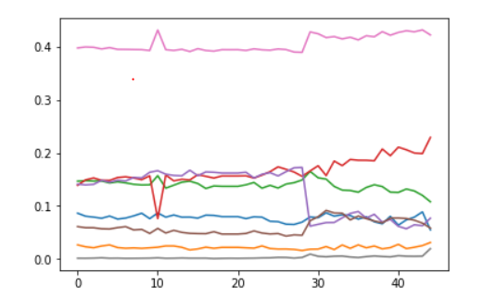

**Shapiro wilk test**

Then we applied shapiro wilk test to check normality of graph.

Statistics=0.954, p=0.000

Taking rolling mean - Then we took rolling mean to get a continues plot on graph.

Applying Dickey-fuller test and taking first difference to make data stationary –

Dickey fuller is used to test if the data is stationary or not. If data is non-stationary then we take first difference to make it stationary.

**Stationary graphs of data**

1 .PPE

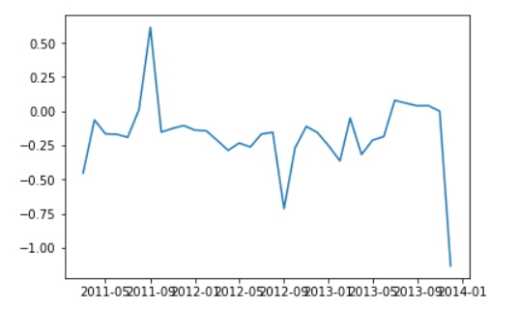

2. Safe acts

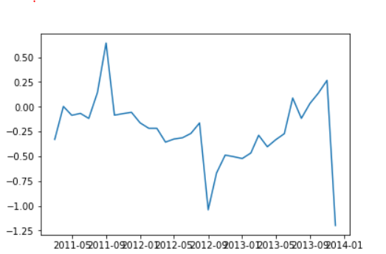

3. safe conditions

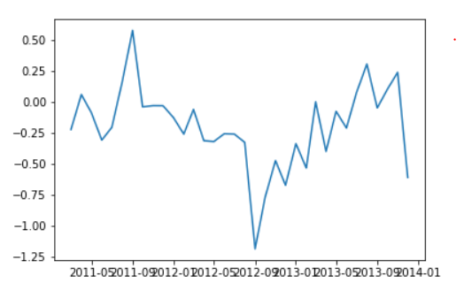

4. unsafe conditions

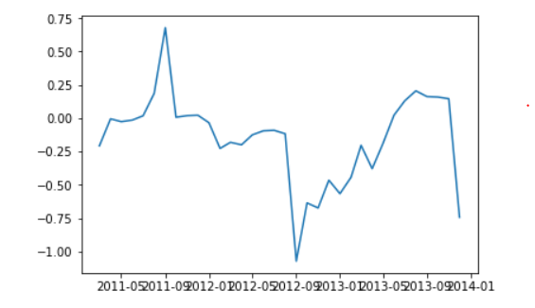

5. unsafe acts

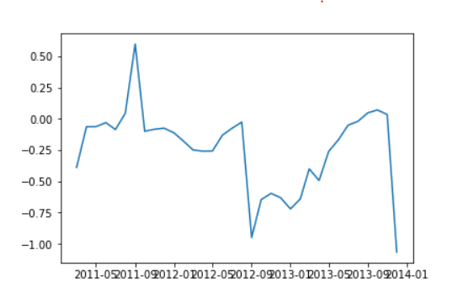

6. procedure

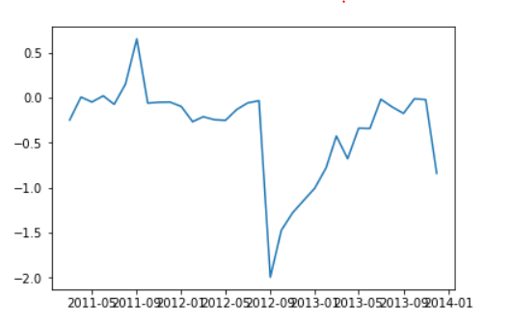

7. safety observations

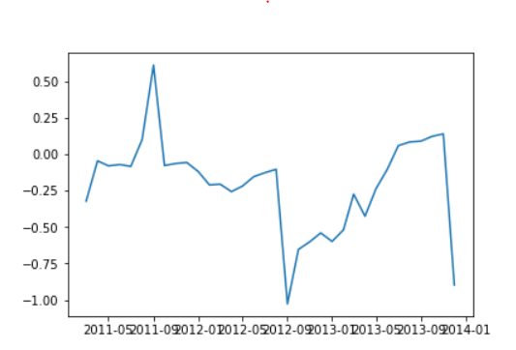

8. TRIFR

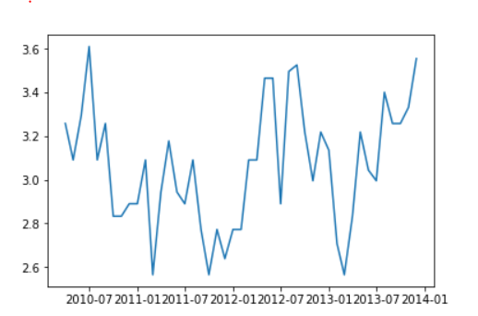

**VAR Results -**

AIC: -41.5458

y1 = safe acts y2= safe conditions

y3 = unsafe acts y4 = unsafe conditions

y5 = procedure y6 = PPE

y7 = safety observations y8 = TRIFR

Results for equation y1

========================================================================

coefficient std. error t-stat prob

------------------------------------------------------------------------

const -20.471902 6.830020 -2.997 0.003

L1.y1 -0.523720 0.297169 -1.762 0.078

L1.y2 -0.004323 0.163485 -0.026 0.979

L1.y3 0.337660 0.651426 0.518 0.604

L1.y4 -0.145358 0.532956 -0.273 0.785

L1.y5 -0.158564 0.466477 -0.340 0.734

L1.y6 0.078203 0.321302 0.243 0.808

L1.y7 -0.070632 2.732425 -0.026 0.979

L1.y8 -0.132505 0.052704 -2.514 0.012

L2.y1 -0.493597 0.378275 -1.305 0.192

L2.y2 -0.327254 0.144975 -2.257 0.024

L2.y3 -0.881002 0.621468 -1.418 0.156

L2.y4 -1.333382 0.590752 -2.257 0.024

L2.y5 -1.092783 0.525936 -2.078 0.038

L2.y6 -0.173592 0.334331 -0.519 0.604

L2.y7 -6.632313 3.210623 -2.066 0.039

L2.y8 -0.076600 0.055901 -1.370 0.171

========================================================================

Results for equation y2

========================================================================

coefficient std. error t-stat prob

------------------------------------------------------------------------

const 12.590376 9.265948 1.359 0.174

L1.y1 1.169605 0.403154 2.901 0.004

L1.y2 -0.101587 0.221792 -0.458 0.647

L1.y3 0.075343 0.883757 0.085 0.932

L1.y4 1.328836 0.723035 1.838 0.066

L1.y5 1.207132 0.632846 1.907 0.056

L1.y6 0.426416 0.435894 0.978 0.328

L1.y7 9.777531 3.706945 2.638 0.008

L1.y8 0.013204 0.071501 0.185 0.853

L2.y1 -0.070718 0.513187 -0.138 0.890

L2.y2 0.097232 0.196680 0.494 0.621

L2.y3 0.379765 0.843115 0.450 0.652

L2.y4 -0.272172 0.801444 -0.340 0.734

L2.y5 -0.300712 0.713512 -0.421 0.673

L2.y6 -0.226118 0.453570 -0.499 0.618

L2.y7 0.070729 4.355692 0.016 0.987

L2.y8 -0.102566 0.075838 -1.352 0.176

========================================================================

Results for equation y3

========================================================================

coefficient std. error t-stat prob

------------------------------------------------------------------------

const -2.877089 3.965998 -0.725 0.468

L1.y1 -0.253067 0.172557 -1.467 0.142

L1.y2 0.012328 0.094931 0.130 0.897

L1.y3 0.667840 0.378264 1.766 0.077

L1.y4 -0.142593 0.309472 -0.461 0.645

L1.y5 -0.141780 0.270870 -0.523 0.601

L1.y6 0.022184 0.186571 0.119 0.905

L1.y7 -2.376309 1.586641 -1.498 0.134

L1.y8 0.025706 0.030604 0.840 0.401

L2.y1 -0.000007 0.219654 -0.000 1.000

L2.y2 -0.016108 0.084183 -0.191 0.848

L2.y3 -0.053794 0.360869 -0.149 0.881

L2.y4 0.043746 0.343033 0.128 0.899

L2.y5 0.108828 0.305396 0.356 0.722

L2.y6 0.074417 0.194137 0.383 0.701

L2.y7 0.662961 1.864317 0.356 0.722

L2.y8 -0.013452 0.032460 -0.414 0.679

========================================================================

Results for equation y4

========================================================================

coefficient std. error t-stat prob

------------------------------------------------------------------------

const 2.632808 11.688141 0.225 0.822

L1.y1 0.335122 0.508542 0.659 0.510

L1.y2 0.102143 0.279770 0.365 0.715

L1.y3 -0.432724 1.114778 -0.388 0.698

L1.y4 0.611065 0.912042 0.670 0.503

L1.y5 0.575350 0.798277 0.721 0.471

L1.y6 0.687191 0.549840 1.250 0.211

L1.y7 3.171227 4.675970 0.678 0.498

L1.y8 0.103256 0.090192 1.145 0.252

L2.y1 -0.583085 0.647338 -0.901 0.368

L2.y2 0.212046 0.248094 0.855 0.393

L2.y3 -0.122294 1.063511 -0.115 0.908

L2.y4 -0.163021 1.010948 -0.161 0.872

L2.y5 -0.257607 0.900029 -0.286 0.775

L2.y6 -0.608383 0.572137 -1.063 0.288

L2.y7 -0.192911 5.494305 -0.035 0.972

L2.y8 -0.013720 0.095662 -0.143 0.886

========================================================================

Results for equation y5

========================================================================

coefficient std. error t-stat prob

------------------------------------------------------------------------

const 6.445438 15.186304 0.424 0.671

L1.y1 0.544386 0.660744 0.824 0.410

L1.y2 0.223910 0.363503 0.616 0.538

L1.y3 -0.537692 1.448421 -0.371 0.710

L1.y4 0.145355 1.185008 0.123 0.902

L1.y5 0.572341 1.037195 0.552 0.581

L1.y6 -0.460126 0.714403 -0.644 0.520

L1.y7 2.459518 6.075449 0.405 0.686

L1.y8 -0.177001 0.117186 -1.510 0.131

L2.y1 0.718617 0.841081 0.854 0.393

L2.y2 0.277553 0.322347 0.861 0.389

L2.y3 0.883245 1.381812 0.639 0.523

L2.y4 0.323850 1.313516 0.247 0.805

L2.y5 0.461914 1.169401 0.395 0.693

L2.y6 0.280096 0.743373 0.377 0.706

L2.y7 -2.461006 7.138704 -0.345 0.730

L2.y8 0.210986 0.124293 1.697 0.090

========================================================================

Results for equation y6

========================================================================

coefficient std. error t-stat prob

------------------------------------------------------------------------

const -1.754683 9.339059 -0.188 0.851

L1.y1 -0.298412 0.406335 -0.734 0.463

L1.y2 -0.165796 0.223542 -0.742 0.458

L1.y3 0.293770 0.890730 0.330 0.742

L1.y4 -0.115310 0.728740 -0.158 0.874

L1.y5 -0.313147 0.637839 -0.491 0.623

L1.y6 0.478117 0.439333 1.088 0.276

L1.y7 -1.733725 3.736194 -0.464 0.643

L1.y8 0.037169 0.072065 0.516 0.606

L2.y1 -0.072602 0.517236 -0.140 0.888

L2.y2 -0.011534 0.198232 -0.058 0.954

L2.y3 0.445211 0.849767 0.524 0.600

L2.y4 0.056475 0.807768 0.070 0.944

L2.y5 0.140789 0.719142 0.196 0.845

L2.y6 0.303486 0.457149 0.664 0.507

L2.y7 1.128341 4.390060 0.257 0.797

L2.y8 -0.027075 0.076436 -0.354 0.723

========================================================================

Results for equation y7

========================================================================

coefficient std. error t-stat prob

------------------------------------------------------------------------

const -1.326337 1.966719 -0.674 0.500

L1.y1 -0.049896 0.085570 -0.583 0.560

L1.y2 -0.028475 0.047076 -0.605 0.545

L1.y3 0.127774 0.187579 0.681 0.496

L1.y4 -0.038234 0.153466 -0.249 0.803

L1.y5 -0.088885 0.134323 -0.662 0.508

L1.y6 -0.049868 0.092520 -0.539 0.590

L1.y7 -0.319387 0.786808 -0.406 0.685

L1.y8 0.012897 0.015176 0.850 0.395

L2.y1 0.018064 0.108925 0.166 0.868

L2.y2 -0.060568 0.041746 -1.451 0.147

L2.y3 -0.165244 0.178953 -0.923 0.356

L2.y4 0.035135 0.170108 0.207 0.836

L2.y5 0.020298 0.151445 0.134 0.893

L2.y6 0.064560 0.096271 0.671 0.502

L2.y7 0.566519 0.924506 0.613 0.540

L2.y8 -0.019548 0.016097 -1.214 0.225

========================================================================

Results for equation y8

========================================================================

coefficient std. error t-stat prob

------------------------------------------------------------------------

const -11.521326 41.706541 -0.276 0.782

L1.y1 0.521924 1.814619 0.288 0.774

L1.y2 -0.839128 0.998298 -0.841 0.401

L1.y3 -1.375444 3.977837 -0.346 0.730

L1.y4 -0.938831 3.254418 -0.288 0.773

L1.y5 -1.334704 2.848474 -0.469 0.639

L1.y6 -0.546647 1.961983 -0.279 0.781

L1.y7 -11.475654 16.685163 -0.688 0.492

L1.y8 0.837600 0.321831 2.603 0.009

L2.y1 -0.298278 2.309884 -0.129 0.897

L2.y2 0.148329 0.885269 0.168 0.867

L2.y3 -0.323451 3.794905 -0.085 0.932

L2.y4 1.094190 3.607344 0.303 0.762

L2.y5 0.482180 3.211555 0.150 0.881

L2.y6 -0.127025 2.041545 -0.062 0.950

L2.y7 10.789133 19.605210 0.550 0.582

L2.y8 -0.178401 0.341349 -0.523 0.601

========================================================================

Coefficient = These are the values for the regression equation for predicting the dependent variable from the independent variable.

Std. error = These are the standard errors associated with the coefficients.

t-stat = coefficient/ std. error

prob = If the p-value is less than the significance level, your sample data provide sufficient evidence to conclude that your regression model fits the data better than the model with no independent variables.

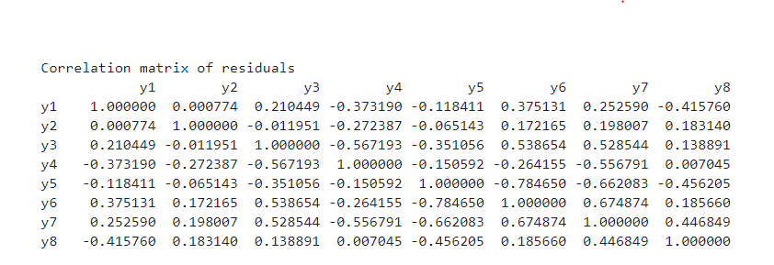

**GRANGER CAUSLITY TEST-**

The **Granger causality test** is a statistical hypothesis **test** for determining whether one time series is useful in forecasting another.

1. PPE and TRIFR

number of lags (no zero) 1

ssr based F test: F=0.0004 , p=0.9841 , df_denom=41, df_num=1

ssr based chi2 test: chi2=0.0004 , p=0.9835 , df=1

number of lags (no zero) 2

ssr based F test: F=0.2666 , p=0.7674 , df_denom=38, df_num=2

ssr based chi2 test: chi2=0.6034 , p=0.7396 , df=2

Granger Causality

number of lags (no zero) 3

ssr based F test: F=0.2280 , p=0.8763 , df_denom=35, df_num=3

ssr based chi2 test: chi2=0.8207 , p=0.8445 , df=3

1. Procedure and TRIFR

number of lags (no zero) 1

ssr based F test: F=0.2470 , p=0.6218 , df_denom=41, df_num=1

ssr based chi2 test: chi2=0.2651 , p=0.6066 , df=1

number of lags (no zero) 2

ssr based F test: F=0.2391 , p=0.7885 , df_denom=38, df_num=2

ssr based chi2 test: chi2=0.5411 , p=0.7629 , df=2

number of lags (no zero) 3

ssr based F test: F=0.4364 , p=0.7283 , df_denom=35, df_num=3

ssr based chi2 test: chi2=1.5711 , p=0.6660 , df=3

1. Safe acts and TRIFR

number of lags (no zero) 1

ssr based F test: F=0.0933 , p=0.7615 , df_denom=41, df_num=1

ssr based chi2 test: chi2=0.1001 , p=0.7517 , df=1

number of lags (no zero) 2

ssr based F test: F=0.0973 , p=0.9075 , df_denom=38, df_num=2

ssr based chi2 test: chi2=0.2202 , p=0.8957 , df=2

number of lags (no zero) 3

ssr based F test: F=0.1349 , p=0.9386 , df_denom=35, df_num=3

ssr based chi2 test: chi2=0.4855 , p=0.9221 , df=3

1. Safe conditions and TRIFR

number of lags (no zero) 1

ssr based F test: F=0.1295 , p=0.7208 , df_denom=41, df_num=1

ssr based chi2 test: chi2=0.1389 , p=0.7094 , df=1

number of lags (no zero) 2

ssr based F test: F=0.0188 , p=0.9814 , df_denom=38, df_num=2

ssr based chi2 test: chi2=0.0425 , p=0.9790 , df=2

umber of lags (no zero) 3

ssr based F test: F=0.1842 , p=0.9064 , df_denom=35, df_num=3

ssr based chi2 test: chi2=0.6632 , p=0.8818 , df=3

1. Unsafe acts and TRIFR

number of lags (no zero) 1

ssr based F test: F=0.0944 , p=0.7602 , df_denom=41, df_num=1

ssr based chi2 test: chi2=0.1014 , p=0.7502 , df=1

number of lags (no zero) 2

ssr based F test: F=0.0980 , p=0.9068 , df_denom=38, df_num=2

ssr based chi2 test: chi2=0.2219 , p=0.8950 , df=2

number of lags (no zero) 3

ssr based F test: F=0.3259 , p=0.8066 , df_denom=35, df_num=3

ssr based chi2 test: chi2=1.1732 , p=0.7594 , df=3

1. Unsafe conditions and TRIFR

number of lags (no zero) 1

ssr based F test: F=0.0180 , p=0.8939 , df_denom=41, df_num=1

ssr based chi2 test: chi2=0.0193 , p=0.8895 , df=1

number of lags (no zero) 2

ssr based F test: F=0.0935 , p=0.9109 , df_denom=38, df_num=2

ssr based chi2 test: chi2=0.2116 , p=0.8996 , df=2

number of lags (no zero) 3

ssr based F test: F=0.2307 , p=0.8744 , df_denom=35, df_num=3

ssr based chi2 test: chi2=0.8306 , p=0.8421 , df=3

1. Safety observations and TRIFR

number of lags (no zero) 1

ssr based F test: F=0.0906 , p=0.7650 , df_denom=41, df_num=1

ssr based chi2 test: chi2=0.0972 , p=0.7552 , df=1

number of lags (no zero) 2

ssr based F test: F=0.0958 , p=0.9089 , df_denom=38, df_num=2

ssr based chi2 test: chi2=0.2168 , p=0.8973 , df=2

number of lags (no zero) 3

ssr based F test: F=0.2850 , p=0.8359 , df_denom=35, df_num=3

ssr based chi2 test: chi2=1.0258 , p=0.7950 , df=3

1. Procedure and a1

number of lags (no zero) 1

ssr based F test: F=0.5516 , p=0.4619 , df_denom=41, df_num=1

ssr based chi2 test: chi2=0.5919 , p=0.4417 , df=1

number of lags (no zero) 2

ssr based F test: F=0.2048 , p=0.8157 , df_denom=38, df_num=2

ssr based chi2 test: chi2=0.4634 , p=0.7932 , df=2

number of lags (no zero) 3

ssr based F test: F=0.6917 , p=0.5633 , df_denom=35, df_num=3

ssr based chi2 test: chi2=2.4901 , p=0.4771 , df=3

1. Procedure and Safe acts

number of lags (no zero) 1

ssr based F test: F=0.6962 , p=0.4089 , df_denom=41, df_num=1

ssr based chi2 test: chi2=0.7472 , p=0.3874 , df=1

number of lags (no zero) 2

ssr based F test: F=0.2775 , p=0.7592 , df_denom=38, df_num=2

ssr based chi2 test: chi2=0.6280 , p=0.7305 , df=2

number of lags (no zero) 3

ssr based F test: F=0.6949 , p=0.5614 , df_denom=35, df_num=3

ssr based chi2 test: chi2=2.5018 , p=0.4750 , df=3

1. Procedure and Safe conditions

number of lags (no zero) 1

ssr based F test: F=6.9540 , p=0.0118 , df_denom=41, df_num=1

ssr based chi2 test: chi2=7.4629 , p=0.0063 , df=1

number of lags (no zero) 2

ssr based F test: F=2.7499 , p=0.0767 , df_denom=38, df_num=2

ssr based chi2 test: chi2=6.2234 , p=0.0445 , df=2

number of lags (no zero) 3

ssr based F test: F=1.7684 , p=0.1712 , df_denom=35, df_num=3

ssr based chi2 test: chi2=6.3661 , p=0.0951 , df=3

1. Procedure and Unsafe acts

number of lags (no zero) 1

ssr based F test: F=1.0162 , p=0.3193 , df_denom=41, df_num=1

ssr based chi2 test: chi2=1.0906 , p=0.2963 , df=1

number of lags (no zero) 2

ssr based F test: F=0.7314 , p=0.4879 , df_denom=38, df_num=2

ssr based chi2 test: chi2=1.6553 , p=0.4371 , df=2

number of lags (no zero) 3

ssr based F test: F=0.7191 , p=0.5473 , df_denom=35, df_num=3

ssr based chi2 test: chi2=2.5886 , p=0.4595 , df=3

1. Procedure and Unsafe conditions

number of lags (no zero) 1

ssr based F test: F=0.2446 , p=0.6236 , df_denom=41, df_num=1

ssr based chi2 test: chi2=0.2625 , p=0.6084 , df=1

number of lags (no zero) 2

ssr based F test: F=0.6353 , p=0.5353 , df_denom=38, df_num=2

ssr based chi2 test: chi2=1.4378 , p=0.4873 , df=2

number of lags (no zero) 3

ssr based F test: F=0.4829 , p=0.6963 , df_denom=35, df_num=3

ssr based chi2 test: chi2=1.7384 , p=0.6284 , df=3

1. Procedure and safety observations

number of lags (no zero) 1

ssr based F test: F=0.8385 , p=0.3652 , df_denom=41, df_num=1

ssr based chi2 test: chi2=0.8998 , p=0.3428 , df=1

number of lags (no zero) 2

ssr based F test: F=0.2611 , p=0.7716 , df_denom=38, df_num=2

ssr based chi2 test: chi2=0.5909 , p=0.7442 , df=2

number of lags (no zero) 3

ssr based F test: F=0.2597 , p=0.8539 , df_denom=35, df_num=3

ssr based chi2 test: chi2=0.9349 , p=0.8170 , df=3

1. Safe acts and Safe conditions

number of lags (no zero) 1

ssr based F test: F=3.3768 , p=0.0734 , df_denom=41, df_num=1

ssr based chi2 test: chi2=3.6238 , p=0.0570 , df=1

number of lags (no zero) 2

ssr based F test: F=2.2207 , p=0.1224 , df_denom=38, df_num=2

ssr based chi2 test: chi2=5.0258 , p=0.0810 , df=2

number of lags (no zero) 3

ssr based F test: F=1.5528 , p=0.2182 , df_denom=35, df_num=3

ssr based chi2 test: chi2=5.5901 , p=0.1333 , df=3

1. Safe acts and Unsafe acts

number of lags (no zero) 1

ssr based F test: F=0.1486 , p=0.7019 , df_denom=41, df_num=1

ssr based chi2 test: chi2=0.1594 , p=0.6897 , df=1

number of lags (no zero) 2

ssr based F test: F=1.6118 , p=0.2129 , df_denom=38, df_num=2

ssr based chi2 test: chi2=3.6477 , p=0.1614 , df=2

number of lags (no zero) 3

ssr based F test: F=0.8339 , p=0.4843 , df_denom=35, df_num=3

ssr based chi2 test: chi2=3.0021 , p=0.3913 , df=3

1. Safe acts and Unsafe conditions

number of lags (no zero) 1

ssr based F test: F=0.0024 , p=0.9614 , df_denom=41, df_num=1

ssr based chi2 test: chi2=0.0025 , p=0.9598 , df=1

number of lags (no zero) 2

ssr based F test: F=0.4922 , p=0.6151 , df_denom=38, df_num=2

ssr based chi2 test: chi2=1.1139 , p=0.5729 , df=2

number of lags (no zero) 3

ssr based F test: F=0.7500 , p=0.5297 , df_denom=35, df_num=3

ssr based chi2 test: chi2=2.7001 , p=0.4402 , df=3

1. Safe acts and safety observations

number of lags (no zero) 1

ssr based F test: F=0.2021 , p=0.6554 , df_denom=41, df_num=1

ssr based chi2 test: chi2=0.2169 , p=0.6414 , df=1

number of lags (no zero) 2

ssr based F test: F=0.2107 , p=0.8109 , df_denom=38, df_num=2

ssr based chi2 test: chi2=0.4769 , p=0.7879 , df=2

number of lags (no zero) 3

ssr based F test: F=0.4185 , p=0.7408 , df_denom=35, df_num=3

ssr based chi2 test: chi2=1.5067 , p=0.6807 , df=3

1. Safe conditions and Unsafe acts

number of lags (no zero) 1

ssr based F test: F=0.0191 , p=0.8908 , df_denom=41, df_num=1

ssr based chi2 test: chi2=0.0205 , p=0.8862 , df=1

number of lags (no zero) 2

ssr based F test: F=3.0340 , p=0.0599 , df_denom=38, df_num=2

ssr based chi2 test: chi2=6.8665 , p=0.0323 , df=2

number of lags (no zero) 3

ssr based F test: F=1.6589 , p=0.1936 , df_denom=35, df_num=3

ssr based chi2 test: chi2=5.9720 , p=0.1130 , df=3

1. Safe conditions and Unsafe conditions

number of lags (no zero) 1

ssr based F test: F=0.4439 , p=0.5090 , df_denom=41, df_num=1

ssr based chi2 test: chi2=0.4764 , p=0.4901 , df=1

number of lags (no zero) 2

ssr based F test: F=0.7183 , p=0.4941 , df_denom=38, df_num=2

ssr based chi2 test: chi2=1.6257 , p=0.4436 , df=2

number of lags (no zero) 3

ssr based F test: F=0.6047 , p=0.6163 , df_denom=35, df_num=3

ssr based chi2 test: chi2=2.1771 , p=0.5365 , df=3

1. Safe conditions and safety observations

number of lags (no zero) 1

ssr based F test: F=0.0408 , p=0.8408 , df_denom=41, df_num=1

ssr based chi2 test: chi2=0.0438 , p=0.8342 , df=1

number of lags (no zero) 2

ssr based F test: F=1.9368 , p=0.1581 , df_denom=38, df_num=2

ssr based chi2 test: chi2=4.3834 , p=0.1117 , df=2

number of lags (no zero) 3

ssr based F test: F=1.1716 , p=0.3345 , df_denom=35, df_num=3

ssr based chi2 test: chi2=4.2178 , p=0.2389 , df=3

1. Unsafe acts and Unsafe conditions

number of lags (no zero) 1

ssr based F test: F=0.0013 , p=0.9712 , df_denom=41, df_num=1

ssr based chi2 test: chi2=0.0014 , p=0.9700 , df=1

number of lags (no zero) 2

ssr based F test: F=1.8020 , p=0.1788 , df_denom=38, df_num=2

ssr based chi2 test: chi2=4.0782 , p=0.1301 , df=2

number of lags (no zero) 3

ssr based F test: F=1.8933 , p=0.1487 , df_denom=35, df_num=3

ssr based chi2 test: chi2=6.8160 , p=0.0780 , df=3

1. Unsafe acts and safety observations

number of lags (no zero) 1

ssr based F test: F=0.1808 , p=0.6729 , df_denom=41, df_num=1

ssr based chi2 test: chi2=0.1941 , p=0.6595 , df=1

number of lags (no zero) 2

ssr based F test: F=3.9252 , p=0.0282 , df_denom=38, df_num=2

ssr based chi2 test: chi2=8.8833 , p=0.0118 , df=2

number of lags (no zero) 3

ssr based F test: F=2.2407 , p=0.1007 , df_denom=35, df_num=3

ssr based chi2 test: chi2=8.0666 , p=0.0447 , df=3

1. Unsafe conditions and safety observations

number of lags (no zero) 1

ssr based F test: F=4.4839 , p=0.0403 , df_denom=41, df_num=1

ssr based chi2 test: chi2=4.8120 , p=0.0283 , df=1

number of lags (no zero) 2

ssr based F test: F=2.2772 , p=0.1164 , df_denom=38, df_num=2

ssr based chi2 test: chi2=5.1536 , p=0.0760 , df=2

number of lags (no zero) 3

ssr based F test: F=1.4830 , p=0.2360 , df_denom=35, df_num=3

ssr based chi2 test: chi2=5.3387 , p=0.1486 , df=3

**Autocorrelation Function (ACF):** It is a measure of the correlation between the the TS with a lagged version of itself.

**Partial Autocorrelation Function (PACF):** This measures the correlation between the TS with a lagged version of itself but after eliminating the variations already explained by the intervening comparisons.

**AUTO-CORRELATION GRAPHS –**

1. PPE

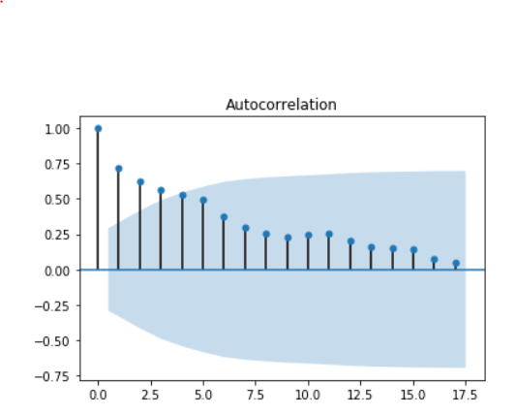

1. Procedure

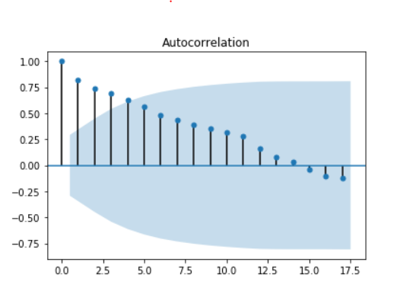

1. Safe acts

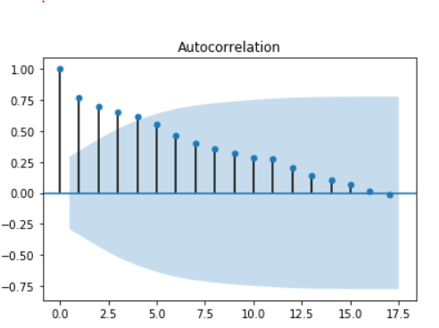

1. Safe conditions

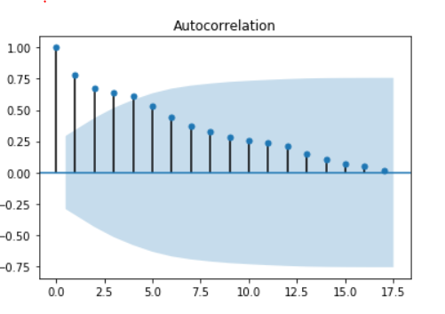

1. Unsafe acts

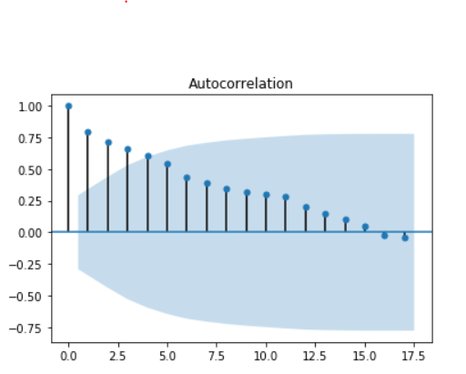

1. Unsafe conditions

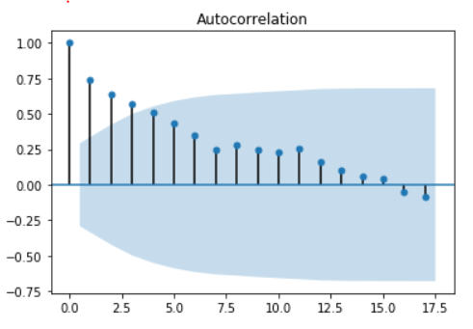

1. Safety observations

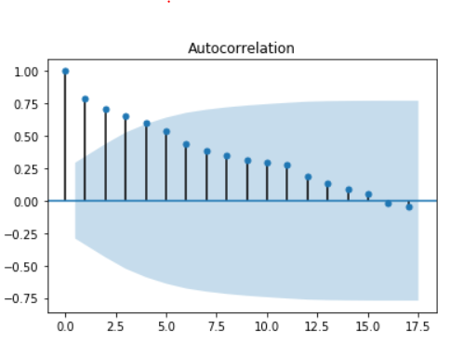

1. TRIFR

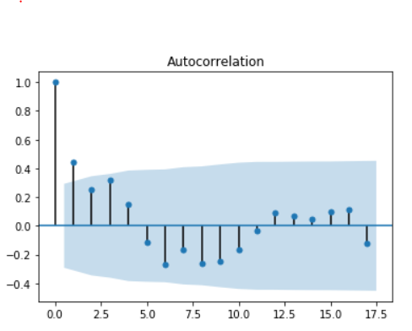

**PARTIAL AUTO-CORRELATION GRAPHS –**

1. **PPE**

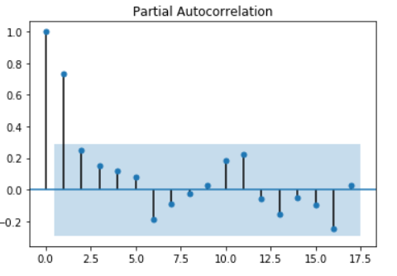

1. **Procedure**

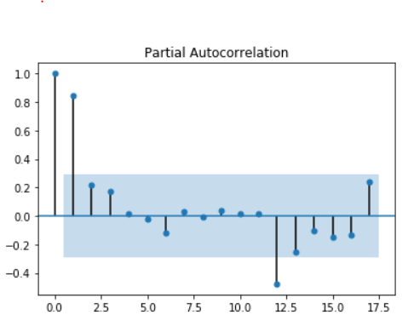

1. **Safe acts**

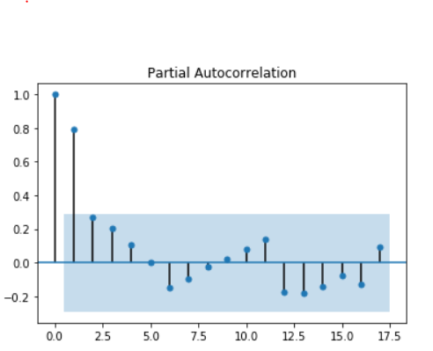

1. **Unsafe acts**

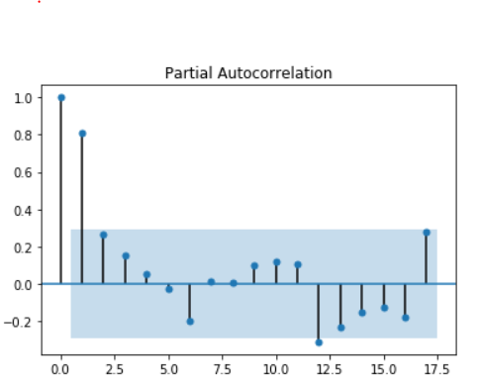

1. **Unsafe conditions**

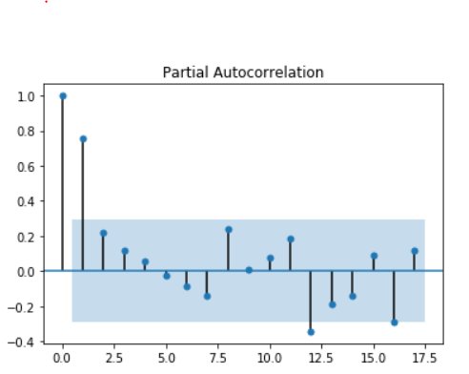

1. **Safety observations**

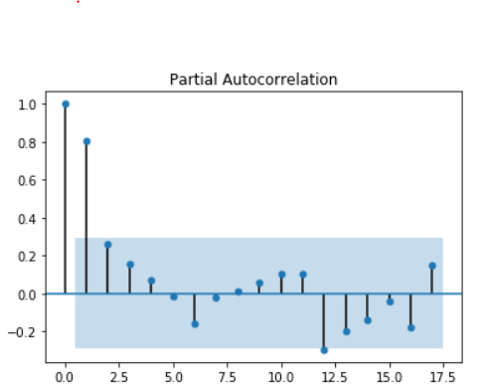

1. **TRIFR**

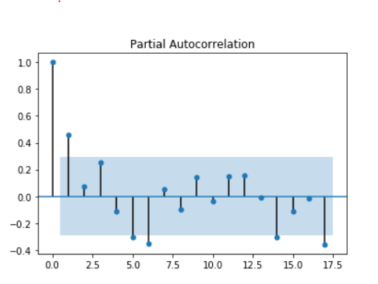

**Change point model**

Change point detection here is done by two methods

1. **Binary segmentation test –**
2. **PELT (Pruned Exact Linear Time) test –**

**Change point graphs –**

1. **Safe acts**

By binary segmentation

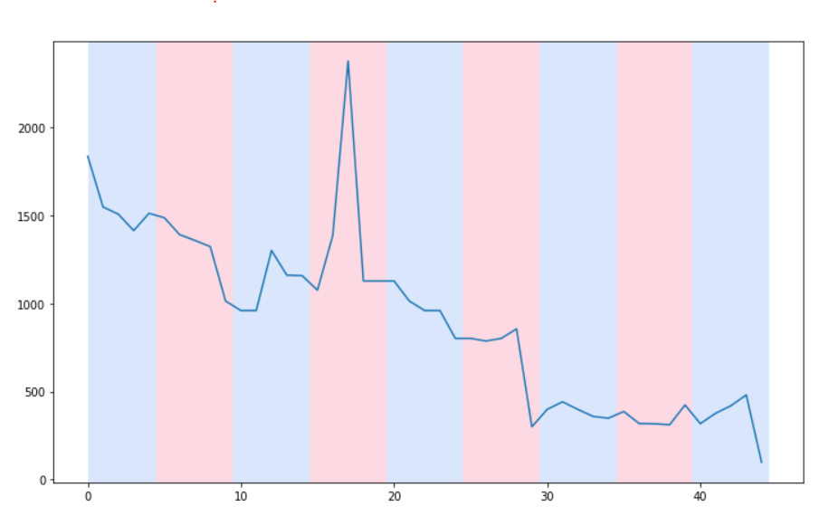

By PELT

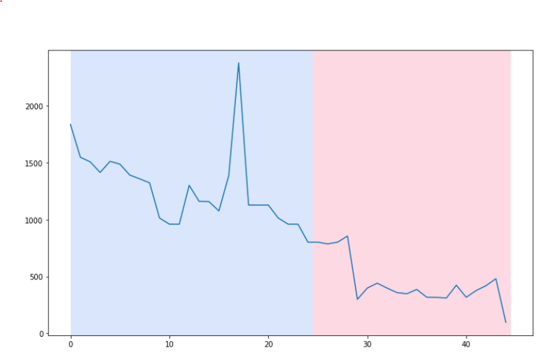

1. **Unsafe acts**

By binary segmentation

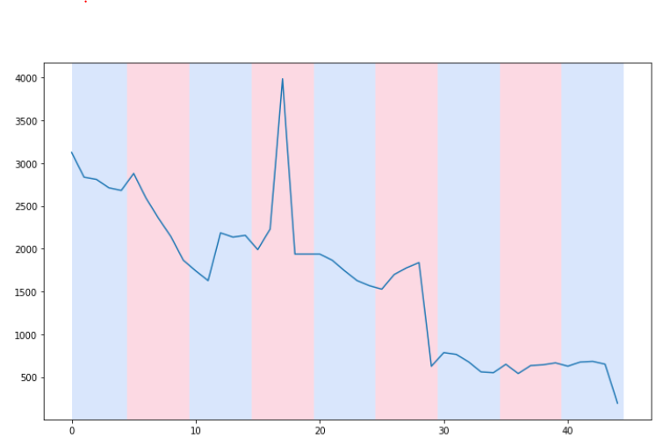

By PELT

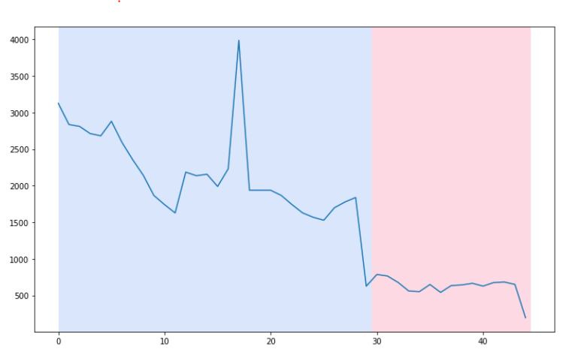

1. **Safe conditions**

By binary segmentation

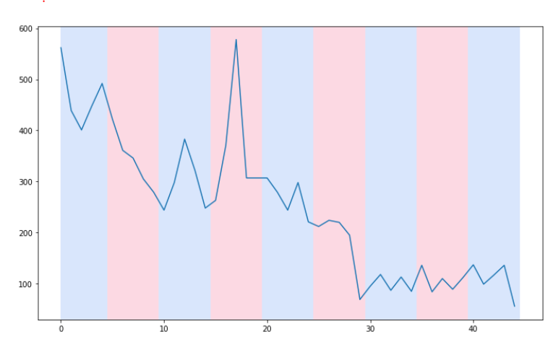

By PELT

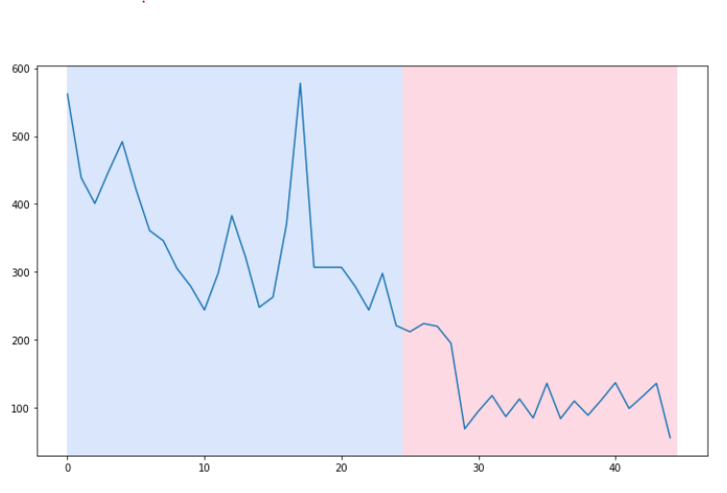

1. **Unsafe conditions**

By binary segmentation

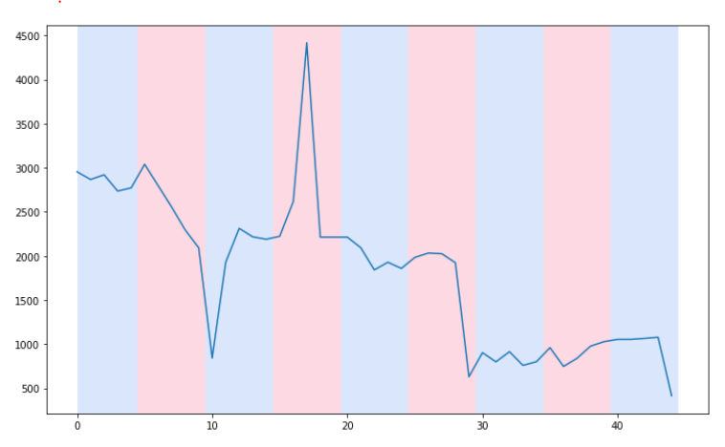

By PELT

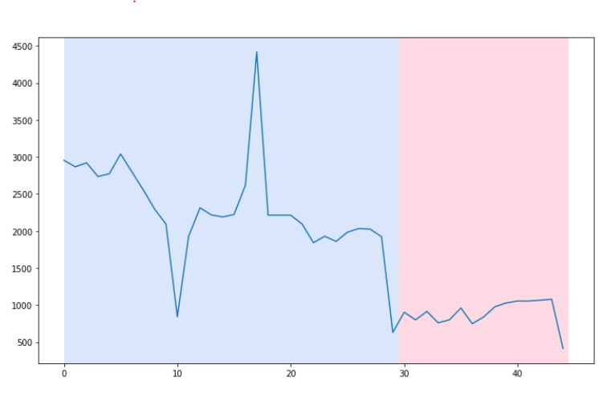

1. **Procedure**

By binary segmentation

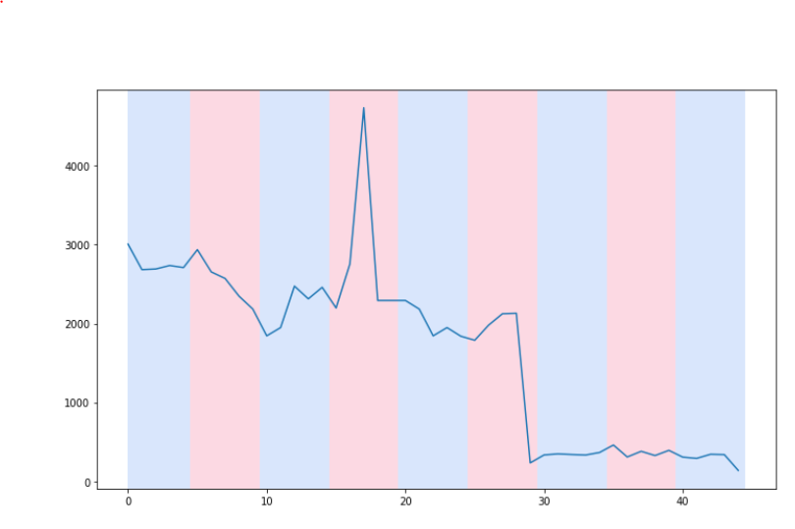

By PELT

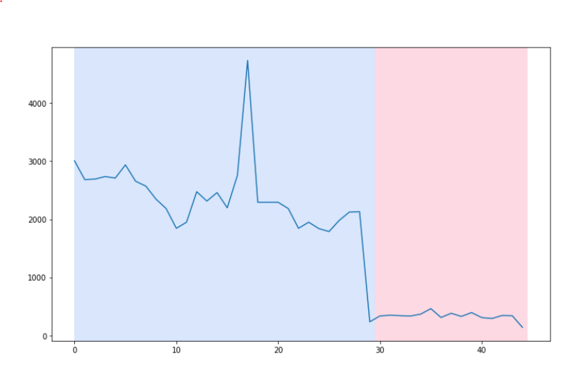

1. **PPE**

By binary segmentation

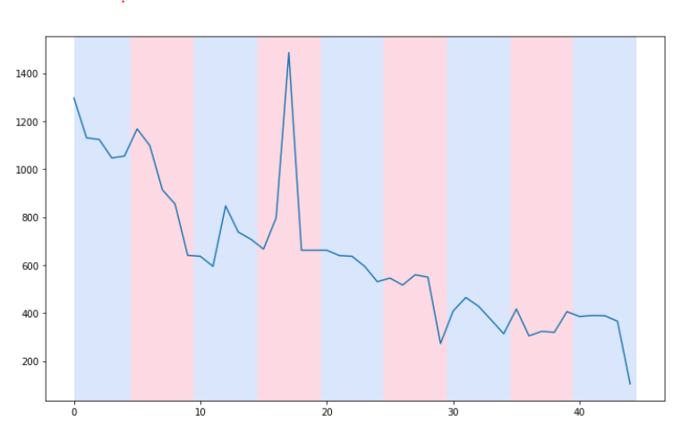

By PELT

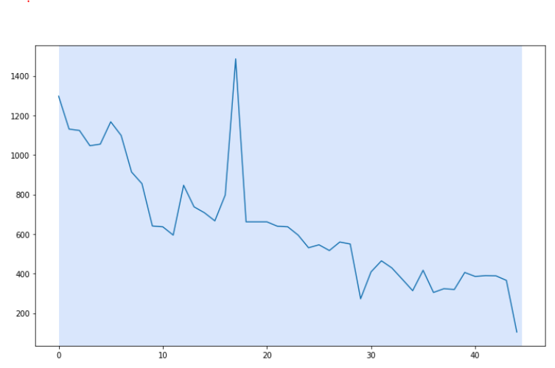

1. **Safety observations**

By binary segmentation

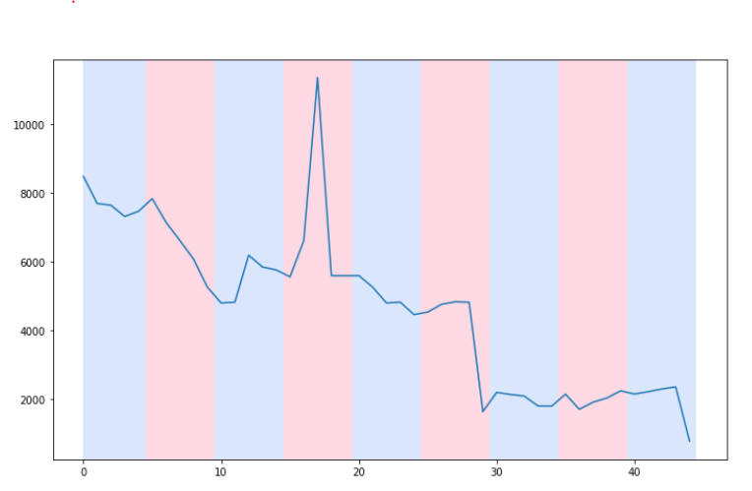

By PELT

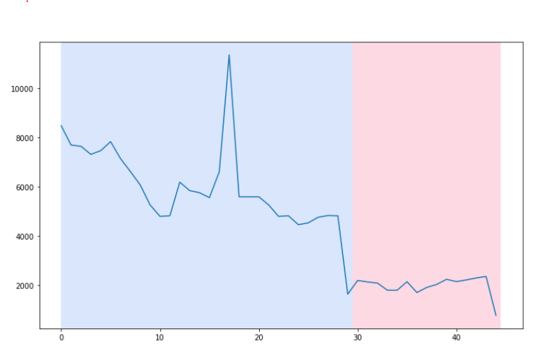

1. **TRIFR**

By binary segmentation

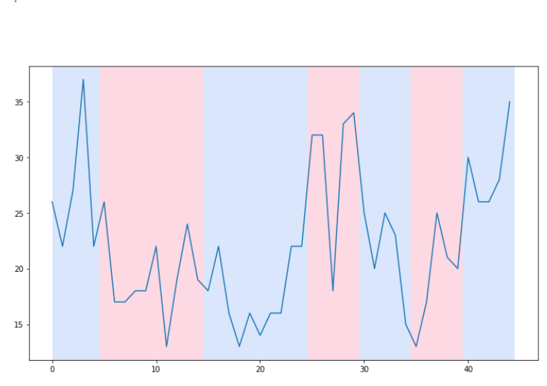

By PELT

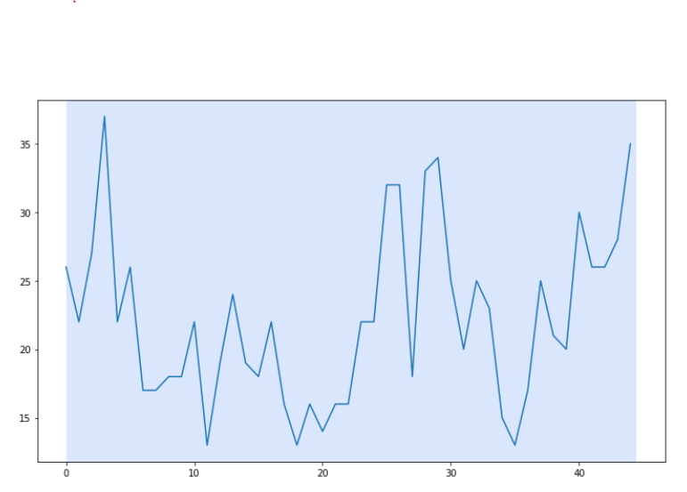

**Maximum Likelihood Estimation Calculation results –**

**Safe acts and TRIFR**

Change point of safe acts = 25

Before 25

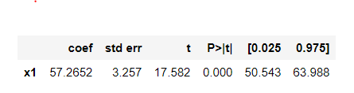

after 25

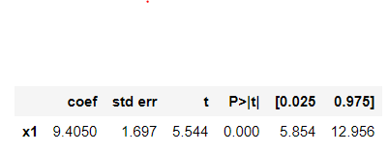

**Safe condition and TRIFR**

Change point of safe conditions = 25

Before 25

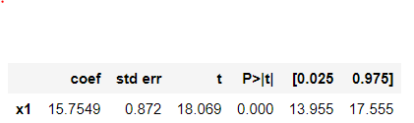

After 25

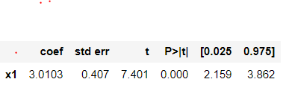

**Unsafe act and TRIFR**

Change point of unsafe acts = 29

Before 29



After 29

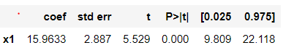

**Unsafe condition and TRIFR**

Change point of unsafe condition = 29

Before 29



After 29



**Procedure and TRIFR**

Change point of procedure = 29

Before 29

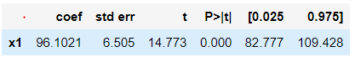

After 29

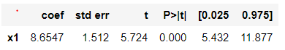

**Safety observation and TRIFR**

Change point of safety observations = 29

Before 29



After 29

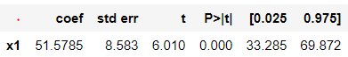

**PPE and TRIFR**

No change point in both

